PYTANIA DLA KLAS 1-3 W KONKURSIE ADWENTOWYM
Pytania należy wydrukować i wyciąć wzdłuż grubszych linii.

Date:  Name:  Class: | Date:  Name:  Class: | Date:  Name:  Class:
How many stars can you see? | What colour is Santa’s hat? | Complete wishes ‘Merry ………….!’
Date:  Name:  Class: | Date:  Name:  Class: | Date:  Name:  Class:
What is it? | How many gifts can you see? | What’s his name?

Date:  Name:  Class: | Date:  Name:  Class: | Date:  Name:  Class:
What colours are these Christmas balls? | Is he happy or sad? | Are these elves boys or girls?
Date:  Name:  Class: | Date:  Name:  Class: | Date:  Name:  Class:
Who helps Santa?  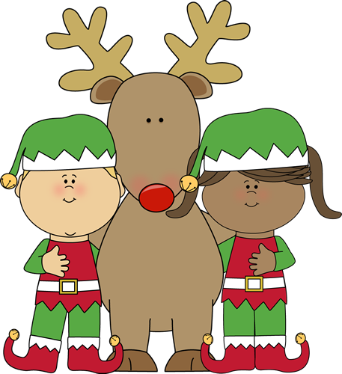 | What’s his name? | What animal is it?
Date:  Name:  Class: | Date:  Name:  Class: | Date:  Name:  Class:
Where was Jesus born?  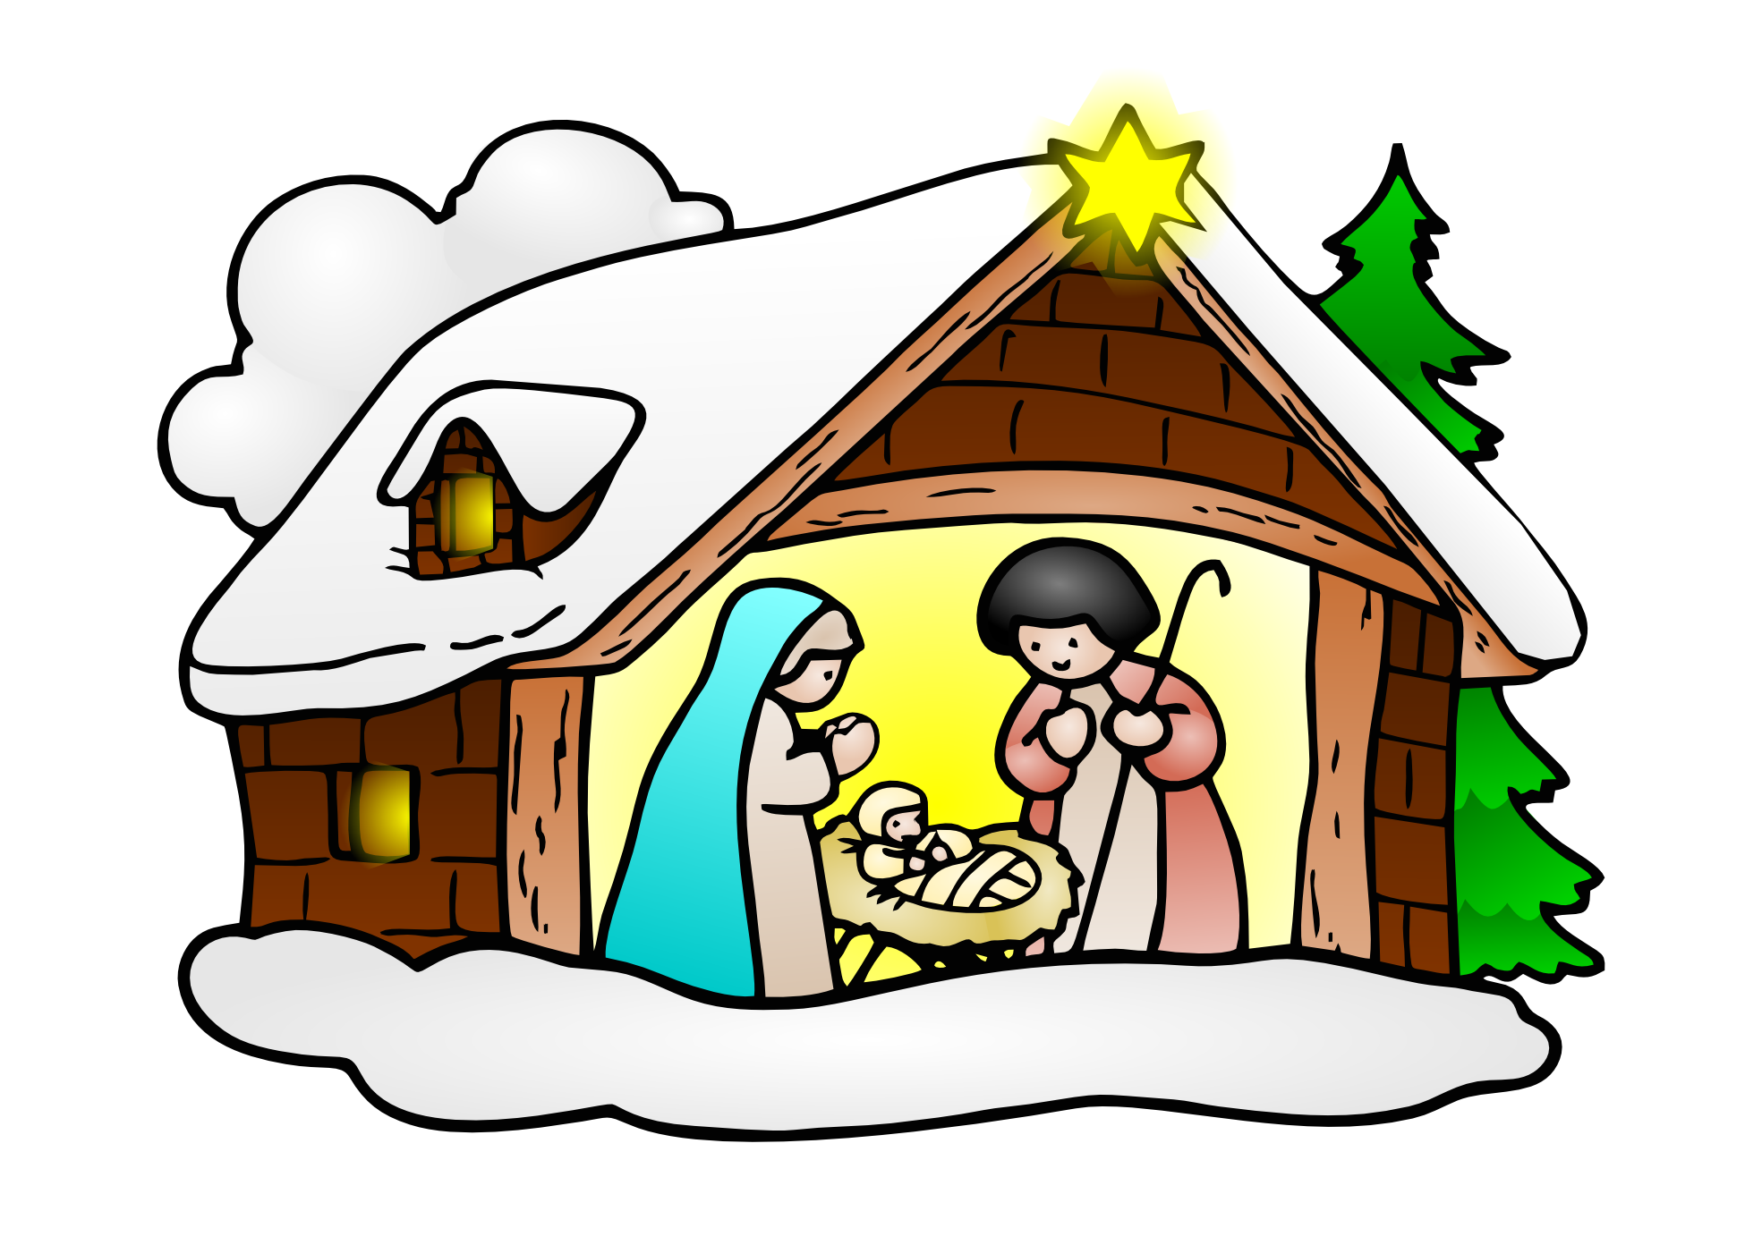 | 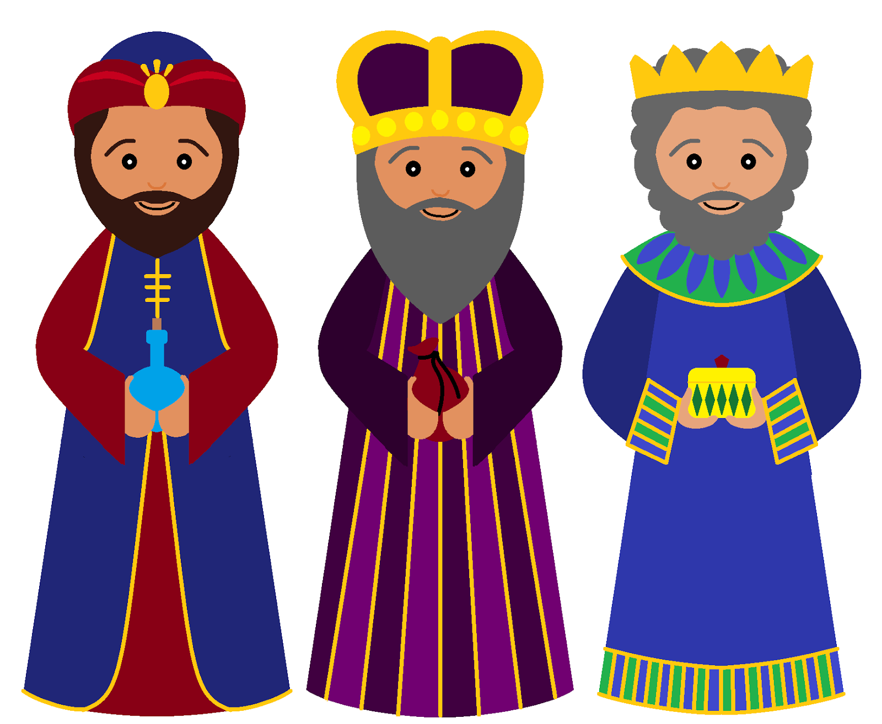  How many Wise Men can you see? | What animal is it?  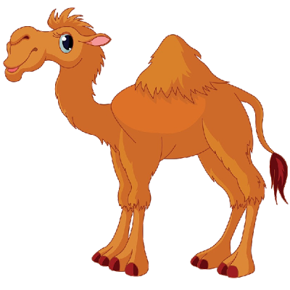

Date:  Name:  Class: | Date:  Name:  Class: | Date:  Name:  Class:
How many Christmas trees can you see? | What is it? | What colour is the snowman’s scarf?
Date:  Name:  Class: | Date:  Name:  Class: | Date:  Name:  Class:
How many candles can you see? | When do we celebrate Christmas? (name a month)

