STUDENT A
Complete the chart asking questions such as the example below:
- What was his/her name? - What was his/her job?
- When was s/he born? - Where was s/he from?
- Was s/he married?
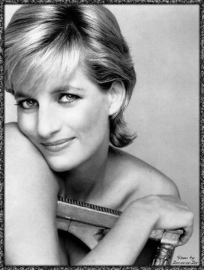 | 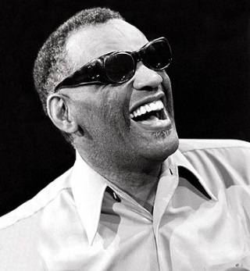 | 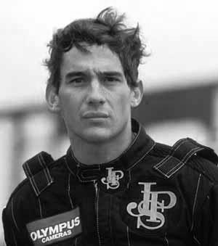 | 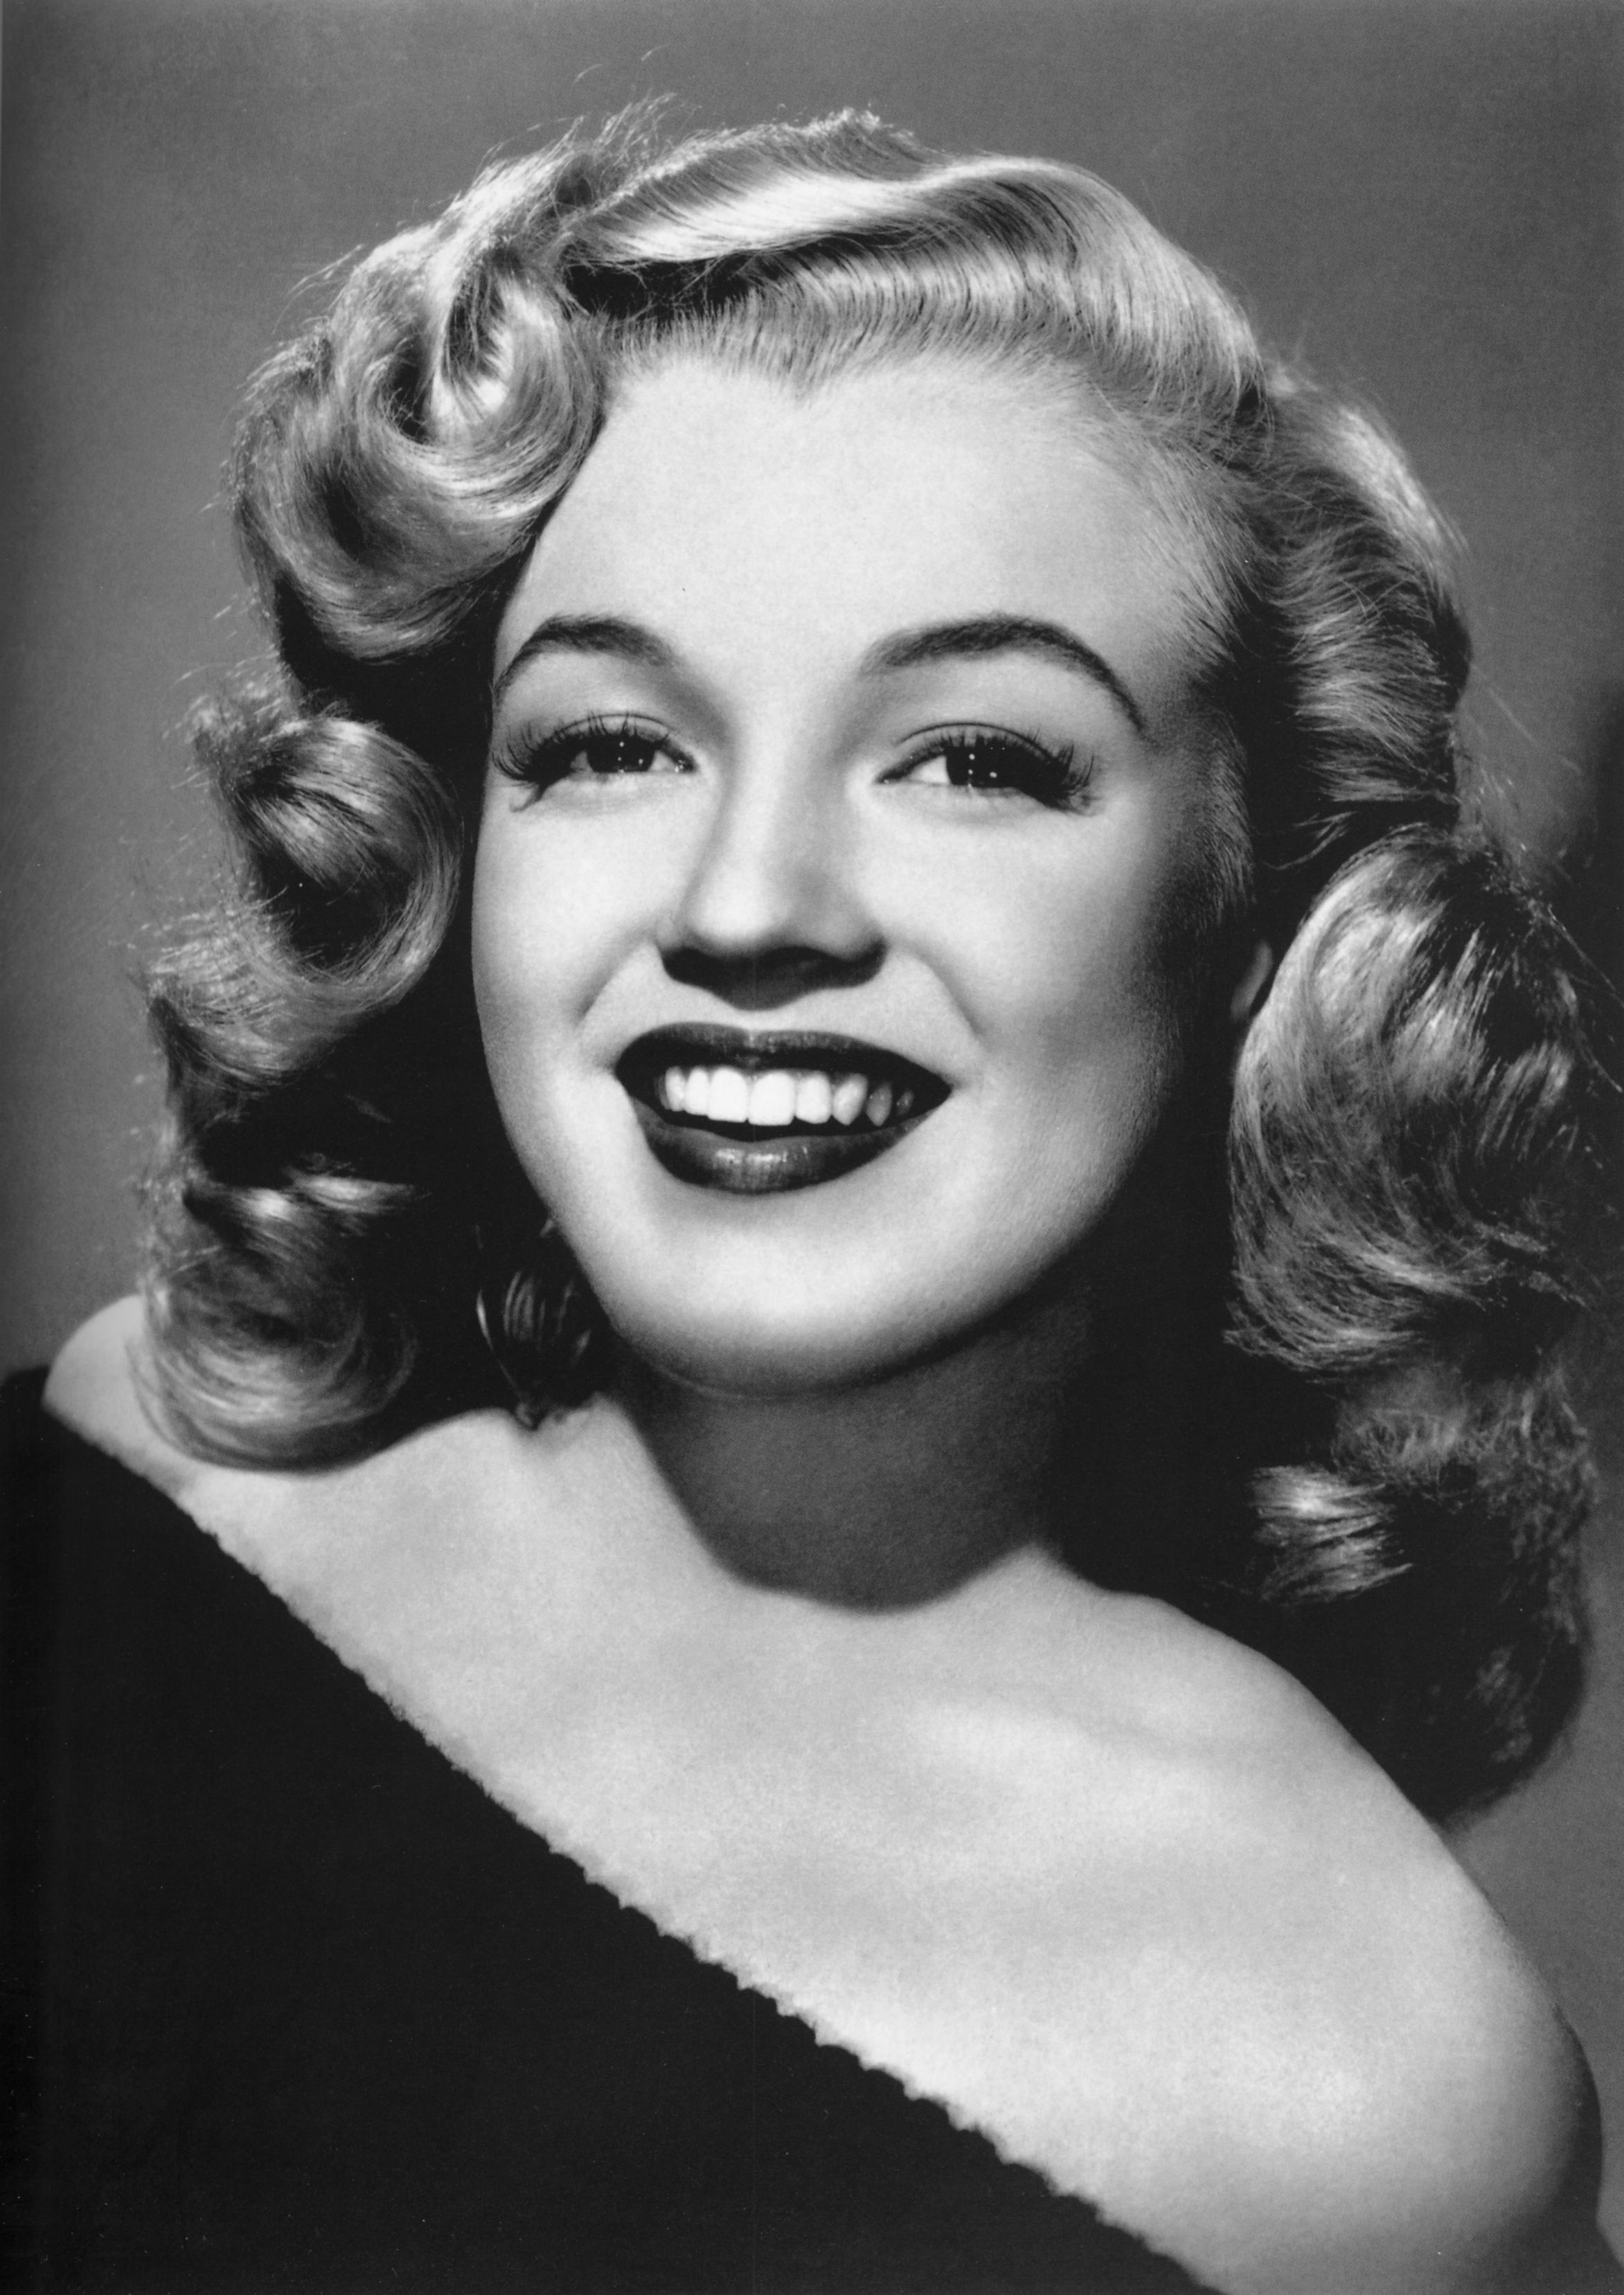
Name: Diana  Job: Princess  Born: July 1 1961  From: England  Status: divorced | Name:  Job:  Born:  From:  Status: | Name: Ayrton Senna  Job: Car Race Driver  Born: March 21 1960  From: Brazil  Status: single | Name:  Job:  Born:  From:  Status:
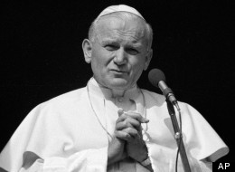 |  | 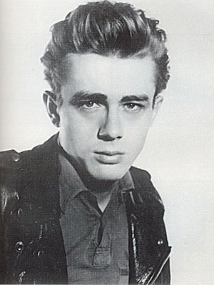 | 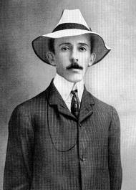
Name: John Paul II  Job: Pope  Born: May 18 1920  From: Poland  Status: Single | Name:  Job:  Born:  From:  Status: | Name: James Dean  Job: Actor  Born: February 8 1931  From: the USA  Status: Single | Name:  Job:  Born:  From:  Status:
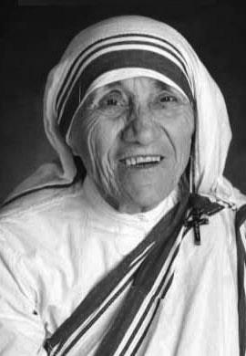 | 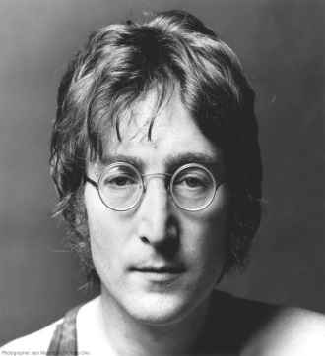 | 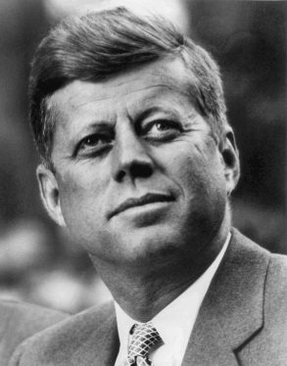 | 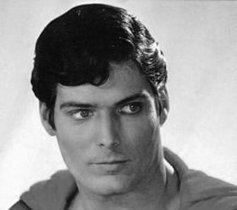
Name: Mother Teresa  Job: Religious  Born: August 26 1910  From: Macedonia  Status: Single | Name:  Job:  Born:  From:  Status: | Name: John Kennedy  Job: Politician  Born: May 29 1917  From: the USA  Status: Married | Name:  Job:  Born:  From:  Status:

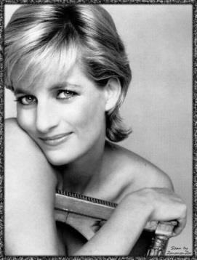
Name:  Job:  Born:  From:  Status: | Name: Ray Charles  Job: Musician  Born: June 10 1930  From: the USA  Status: Divorced | Name:  Job:  Born:  From:  Status: | Name: Marilyn Monroe  Job: Actress  Born: June 1 1926  From: the USA  Status: Divorced
Name:  Job:  Born:  From:  Status: | Name: Elvis Presley  Job: Musician  Born: January 8 1935  From: the USA  Status: Divorced | Name:  Job:  Born:  From:  Status: | Name: Santos Dumont  Job: Scientist  Born: July 20 1873  From: Brazil  Status: Single
Name:  Job:  Born:  From:  Status: | Name: John Lennon  Job: Musician  Born: October 9 1940  From: England  Status: Married | Name:  Job:  Born:  From:  Status: | Name: Christopher Reeve  Job: Actor  Born: Sept. 25 1952  From: the USA  Status: Married
STUDENT B
Complete the chart asking questions such as the example below:
- What was his/her name? - What was his/her job?
- When was s/he born? - Where was s/he from?
- Was s/he married?

