|  |  |  |  |
| --- | --- | --- | --- |
| B | A | L | L |



|  |  |  |  |  |
| --- | --- | --- | --- | --- |
| T | R | A | I | N |

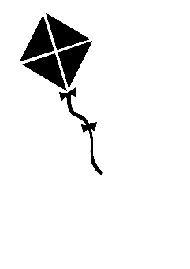

|  |  |  |  |
| --- | --- | --- | --- |
| K | I | T | E |

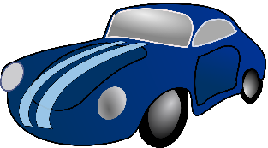

|  |  |  |
| --- | --- | --- |
| C | A | R |

|  |  |  |  |  |  |  |  |
| --- | --- | --- | --- | --- | --- | --- | --- |
| S | P | A | C | E | M | A | N |

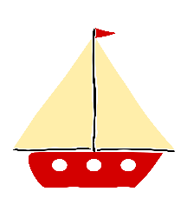

|  |  |  |  |
| --- | --- | --- | --- |
| B | O | A | T |



|  |  |  |  |
| --- | --- | --- | --- |
| D | O | L | L |



|  |  |  |  |  |
| --- | --- | --- | --- | --- |
| T | E | D | D | Y |
| B | E | A | R |  |
| B |  | L | L |



|  |  |  |  |  |
| --- | --- | --- | --- | --- |
| T |  | A |  | N |



|  |  |  |  |
| --- | --- | --- | --- |
| K |  | T | E |



|  |  |  |
| --- | --- | --- |
|  | A | R |

|  |  |  |  |  |  |  |  |
| --- | --- | --- | --- | --- | --- | --- | --- |
| S | P |  | C | E | M | A |  |



|  |  |  |  |
| --- | --- | --- | --- |
| B | O |  | T |



|  |  |  |  |
| --- | --- | --- | --- |
| D |  | L | L |



|  |  |  |  |  |
| --- | --- | --- | --- | --- |
| T | E |  |  | Y |
| B | E |  | R |  |
|  |  |  |  |



|  |  |  |  |  |
| --- | --- | --- | --- | --- |
|  |  |  |  |  |



|  |  |  |  |
| --- | --- | --- | --- |
|  |  |  |  |



|  |  |  |
| --- | --- | --- |
|  |  |  |

|  |  |  |  |  |  |  |  |
| --- | --- | --- | --- | --- | --- | --- | --- |
|  |  |  |  |  |  |  |  |



|  |  |  |  |
| --- | --- | --- | --- |
|  |  |  |  |



|  |  |  |  |
| --- | --- | --- | --- |
|  |  |  |  |



|  |  |  |  |  |
| --- | --- | --- | --- | --- |
|  |  |  |  |  |
|  |  |  |  |  |